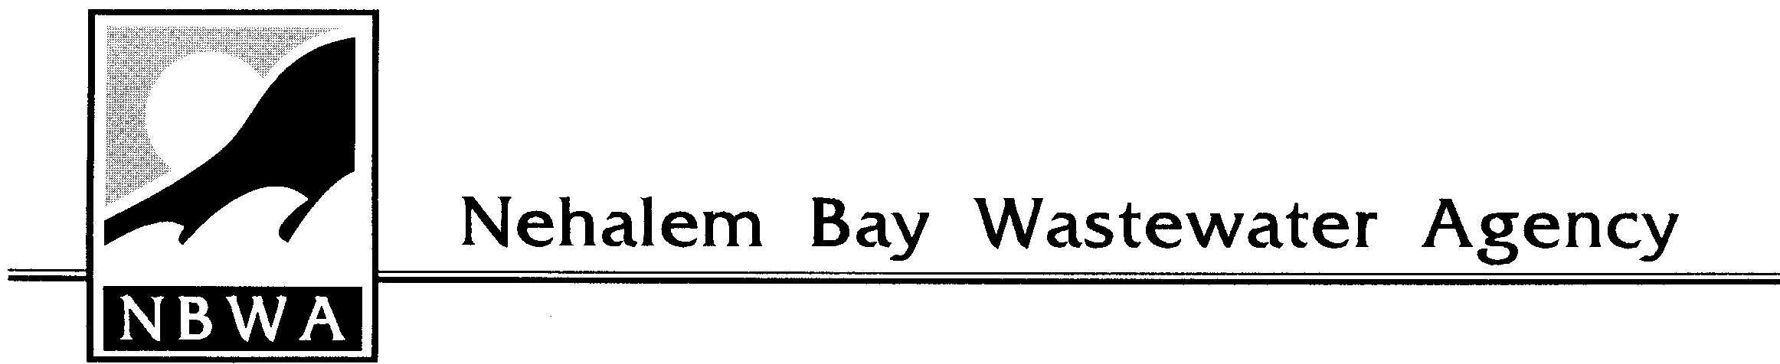
AGENDA
REGULAR MEETING OF THE BOARD OF DIRECTORS
July 17, 2019 - 1:00 p.m.

1. WELCOME TO VISITORS

2. SWEARING IN OF DIRECTORS
#1-John Handler
#2-David Wilson

3. ELECTION OF OFFICERS
Chairman & Vice Chairman

4. MINUTES - Regular meeting of June 19, 2019

5. FINANCIAL REPORT - For the month ending May 31, 2019

6. UNFINISHED BUSINESS
A). Resolution 2019-07: Establishing New Connection and System Development Charges and an Assessment Method
(Amending Resolution 97-9)
B). Resolution 2019-08: A Methodology for Defining the Sewer Use Charges
(Amending Resolution 96-01)

7. NEW BUSINESS

8. MANAGERS REPORT
A) Projects Update

9. BOARD COMMENTS

10. PUBLIC COMMENTS

